271-[DF]-Lab - Performing a Conditional Search
Task 2: Query the world database
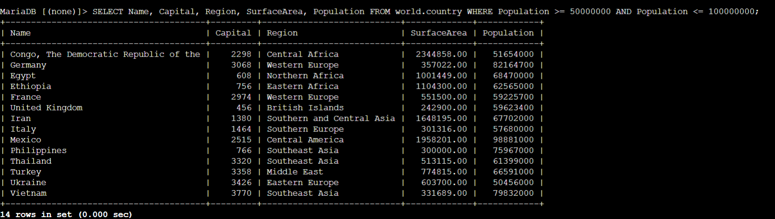
To return the same records as the previous result set by using the BETWEEN operator
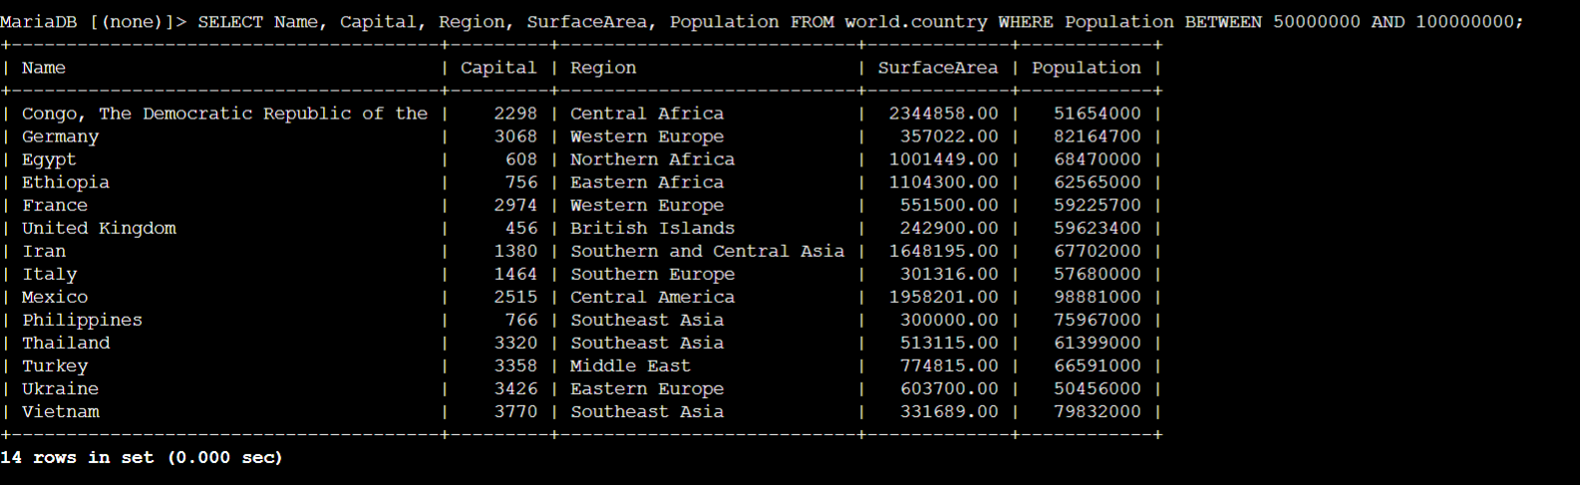
To return the population of all European countries by using the LIKE function and SUM function
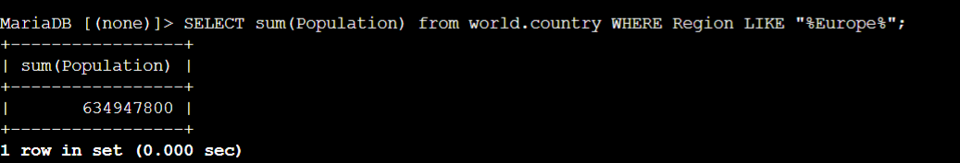
To return the same information as the previous query with the column alias,
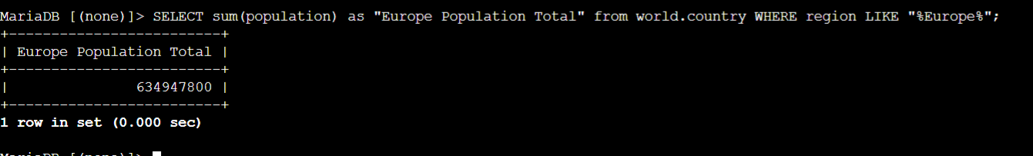
To perform a case-sensitive search by using the LOWER function, run the following query.
